EXPLORATORY DATA ANALYSIS
E-Commerce Sales Dataset
EDA Report
Submitted By:
Ankita Shinde
Subject:
Exploratory Data Analysis
Tools Used:
Python, Pandas, NumPy, Matplotlib, Seaborn, Microsoft Word
Dataset:
E-Commerce Sales Dataset
Academic Year:
2026

1. Introduction
Exploratory Data Analysis (EDA) is an important process in data analysis that helps us understand the structure, characteristics and patterns present in a dataset. It involves examining the data using statistical methods and visualizations before performing further analysis.
In this project, Exploratory Data Analysis is performed on an E-Commerce Sales Dataset. The dataset contains information related to customer details, products, sales, quantity, price, discounts, payment methods, cities, order dates and customer ratings.
The main purpose of EDA is to understand what information is available in the dataset, identify patterns and relationships between different variables, check the quality of the data, and generate meaningful insights from the available information.
Various Python libraries such as Pandas, NumPy, Matplotlib and Seaborn are used to perform data analysis and create visualizations.

2. Objective of the Project
The main objectives of this project are:
- To understand the structure and contents of the E-Commerce Sales Dataset.
- To identify the different types of variables available in the dataset.
- To check the dataset for missing values and duplicate records.
- To understand customer demographics such as age and gender.
- To analyze product categories and sales performance.
- To study the relationship between price, quantity, discount and sales.
- To analyze customer ratings and their relationship with sales.
- To understand the distribution of payment methods and cities.
- To identify trends and patterns in sales using data visualization.
- To generate meaningful business insights from the dataset.

3. Dataset Description
The dataset used for this project is an E-Commerce Sales Dataset. It contains information about customer orders, products, sales transactions and customer feedback.
The dataset consists of 20 records and 13 columns.
The available information in the dataset includes:
- Order_ID: Unique identification number assigned to each order.
- Customer_Age: Age of the customer who placed the order.
- Gender: Gender of the customer.
- Category: Category of the product purchased.
- Product: Name of the product purchased.
- Quantity: Number of units purchased in the order.
- Price: Price of the product.
- Discount: Discount provided on the product/order.
- Payment: Payment method used by the customer.
- City: City associated with the order.
- Order_Date: Date on which the order was placed.
- Rating: Rating given by the customer.
- Sales: Total sales amount generated from the order.
The dataset contains both numerical and categorical variables. Numerical variables can be used for statistical analysis, while categorical variables are useful for understanding groups and categories.

4. Dataset Structure
The dataset was loaded into Python using the Pandas library. The head() function was used to display the first five records of the dataset.
This helps us understand how the data is organized and provides an initial view of the available columns and values.

Python Code:
df.head()

Output:
The first five records of the E-Commerce Sales Dataset are displayed below.
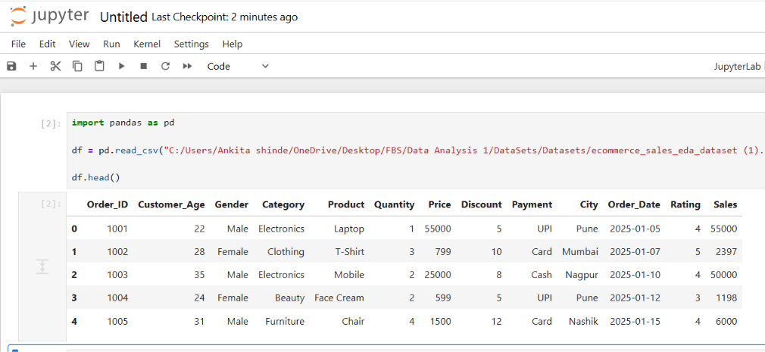

5. Dataset Dimensions
The shape function is used to determine the number of rows and columns present in the dataset.
Python Code:
print(df.shape)
Output:
(20, 13)
Observation:
The dataset contains 20 records (rows) and 13 variables (columns). Each row represents an e-commerce order, while each column represents a specific attribute related to the order, customer, product or transaction.
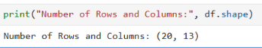

6. Dataset Information
The info() function is used to obtain detailed information about the dataset. It displays the column names, number of non-null values and data types of each column.
Python Code:
df.info()
Observation:
The dataset contains 13 columns with different data types. Numerical columns include customer age, quantity, price, discount, rating and sales, while categorical columns include gender, category, product, payment and city. The order date column contains information about the date of the transaction.
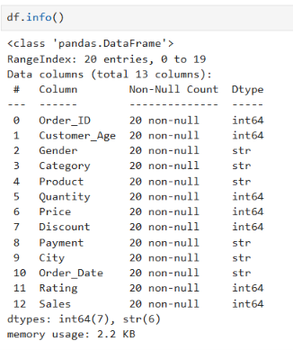

7. Statistical Summary
The describe() function is used to obtain the statistical summary of numerical variables in the dataset.
Python Code:
df.describe()
Observation:
The statistical summary provides important measures such as count, mean, standard deviation, minimum value, maximum value and quartiles. This helps in understanding the distribution and range of numerical variables such as customer age, quantity, price, discount, rating and sales.
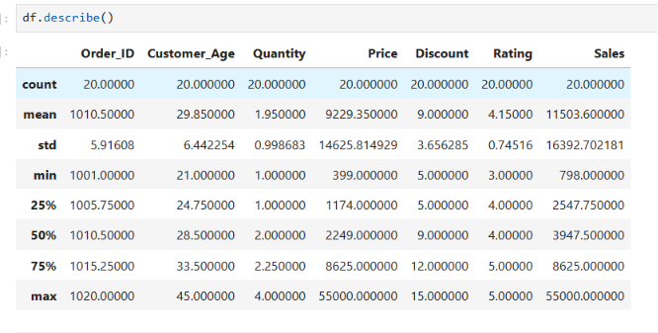

8. Missing Value Analysis
Missing values were checked using the isnull().sum() function.
Python Code:
print(df.isnull().sum())
Observation:
The analysis shows that there are no missing values in the dataset. All 13 columns contain complete information for the available records. Therefore, no missing-value imputation is required for this dataset.
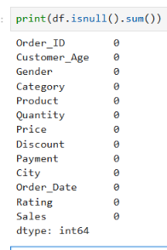
9. Duplicate Record Analysis
Duplicate records were checked using the duplicated() function.
Python Code:
print(df.duplicated().sum())
Observation:
The dataset was checked for duplicate records. The result indicates whether any identical records are present in the dataset. Duplicate records, if found, should be removed before performing further analysis to avoid incorrect results.
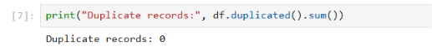

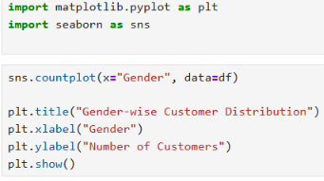
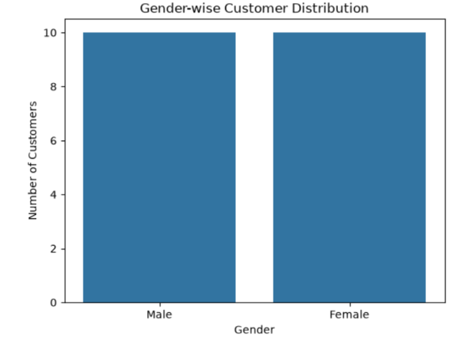
1. Gender-wise Customer Distribution
A count plot is used to analyze the distribution of customers based on gender. The graph represents the number of male and female customers present in the dataset.
Observation:
The gender-wise distribution helps us understand the customer composition of the dataset. It shows the number of orders contributed by each gender and allows comparison between male and female customers.
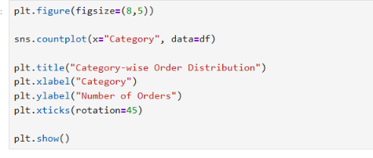
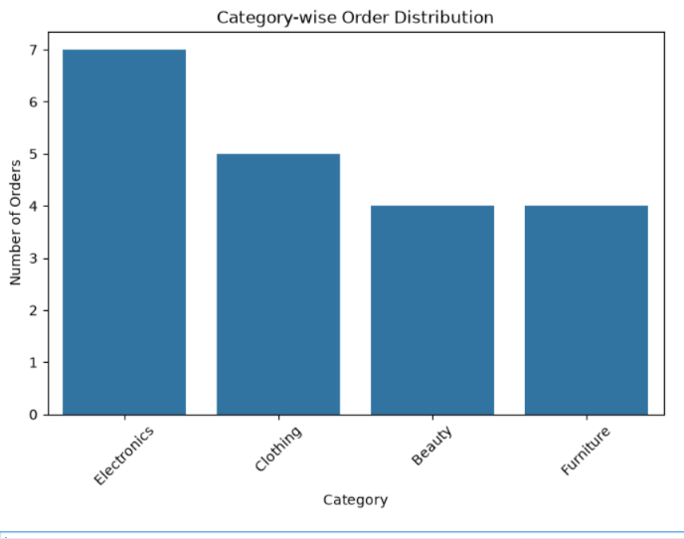
2.Category-wise Order Distribution
The category-wise distribution shows the number of orders belonging to different product categories. This analysis helps in understanding which product categories are more frequently purchased by customers.
Observation:
The graph compares the number of orders across different product categories. Categories with higher bars represent products that have received more orders in the given dataset.
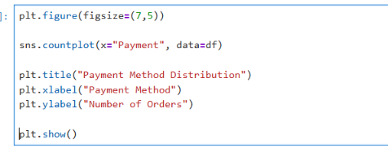
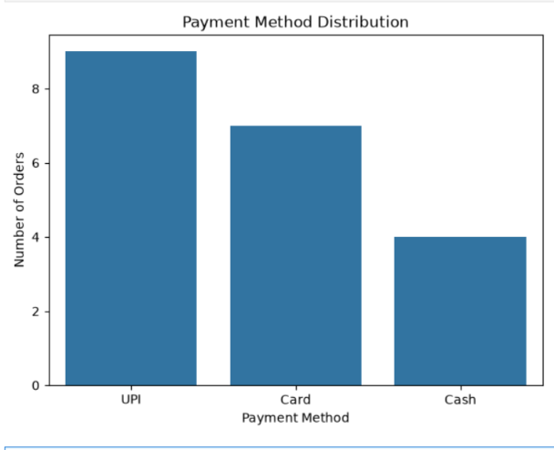
3. Payment Method Distribution
The payment method analysis shows the different payment methods used by customers to complete their purchases.
Observation:
The graph provides a comparison of the number of orders made using different payment methods. It helps identify the most commonly used payment method among the customers in the dataset.
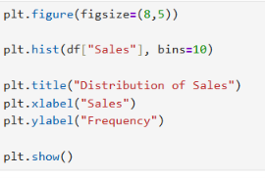

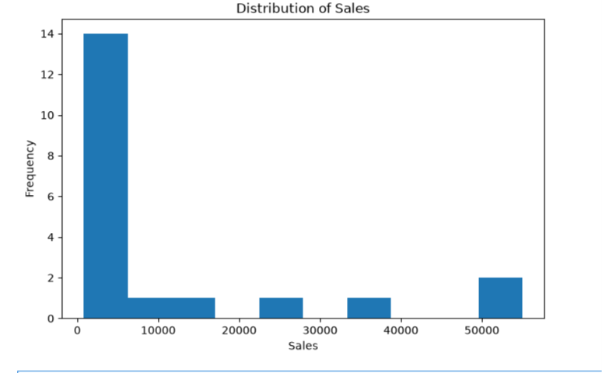
4. Sales Distribution
A histogram is used to understand the distribution of sales values in the dataset. It shows how frequently different sales ranges occur.
Observation:
The histogram shows the distribution of sales amounts across the orders. It helps identify the sales ranges in which most of the orders are concentrated and provides an overall understanding of the sales pattern.
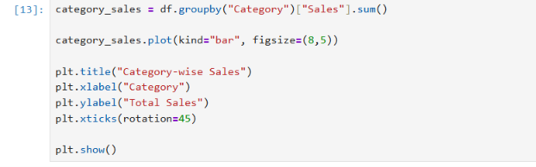
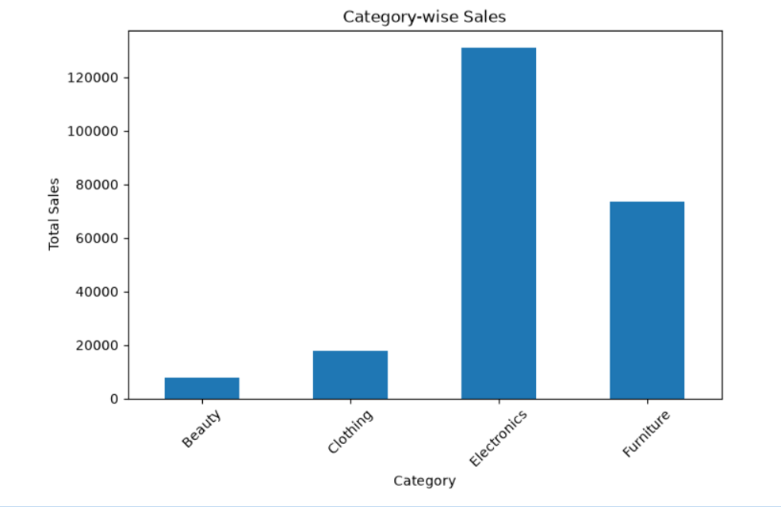
5. Category-wise Sales Analysis
Category-wise sales analysis is performed to compare the total sales generated by different product categories.
The groupby() function is used to group the records according to product category and calculate the total sales for each category.
Observation:
The bar chart compares the total sales generated by different product categories. The category with the highest bar contributes the highest total sales, while the category with the lowest bar contributes the least sales.
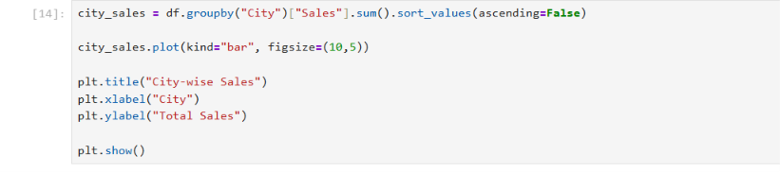
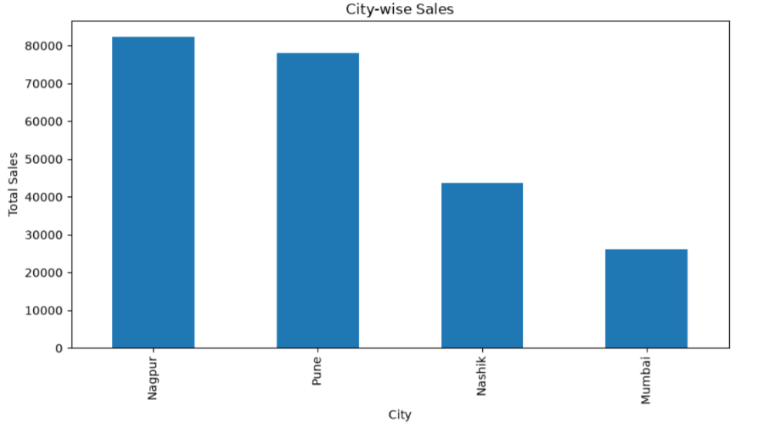
6. City-wise Sales Analysis
City-wise sales analysis is used to understand the contribution of different cities to the overall sales.
The total sales for each city are calculated by grouping the dataset according to the City column.
Observation:
The graph compares total sales across different cities. It helps identify the cities that contribute more to the overall sales and the cities with comparatively lower sales.
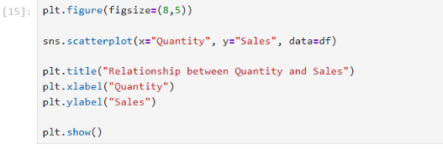

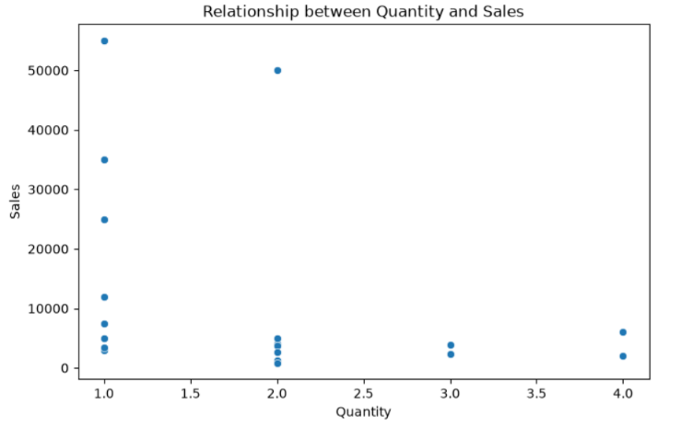7. Relationship between Quantity and Sales
A scatter plot is used to study the relationship between the quantity of products purchased and the sales amount.
Observation:
The scatter plot shows how sales values change with the quantity of products purchased. It helps us understand whether higher quantities are generally associated with higher sales.
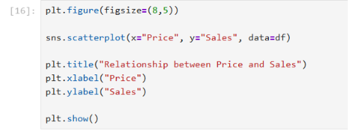
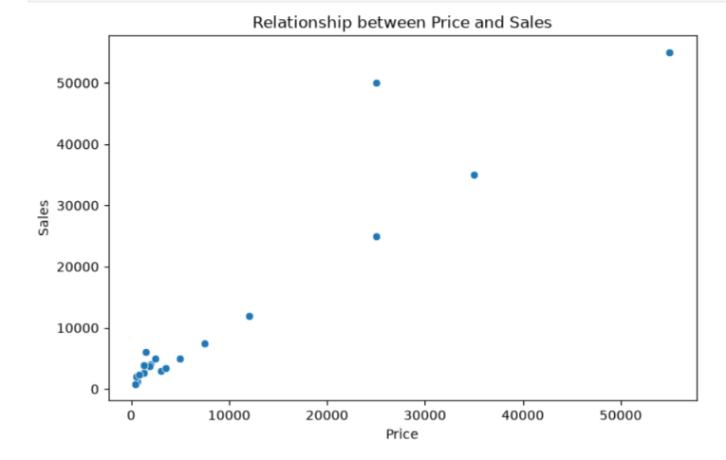
8. Relationship between Price and Sales
A scatter plot is used to analyze the relationship between product price and sales amount.
Observation:
The plot shows how sales values vary with product price. This analysis helps understand whether higher-priced products are associated with higher sales amounts.
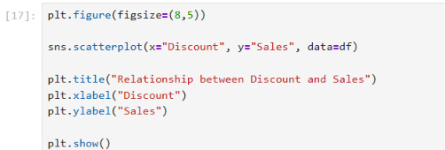
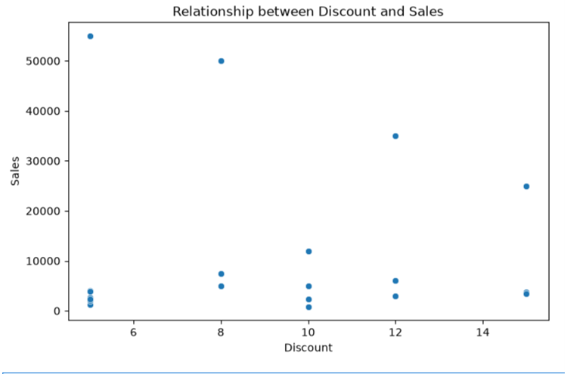
10.9 Relationship between Discount and Sales
A scatter plot is used to study the relationship between the discount offered and the sales amount.
Observation:
The graph shows the variation in sales for different discount values. This helps in understanding whether changes in discount are associated with changes in sales.
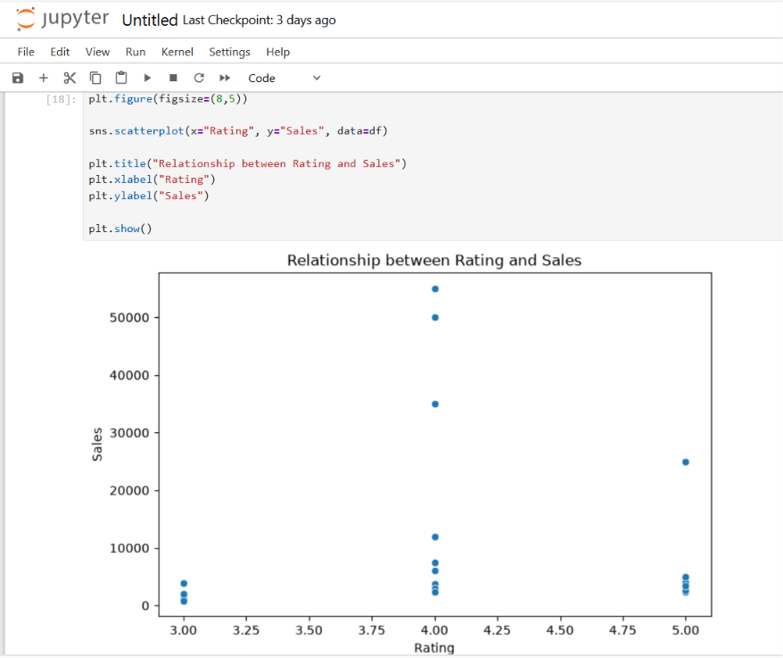
10. Relationship between Rating and Sales
A scatter plot is used to examine the relationship between customer ratings and sales amount.
Observation:
The scatter plot shows the distribution of sales values for different customer ratings. It helps us understand whether customer ratings have any visible relationship with sales.

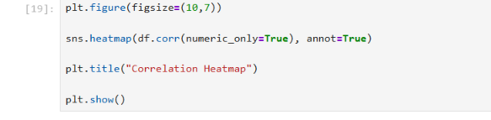

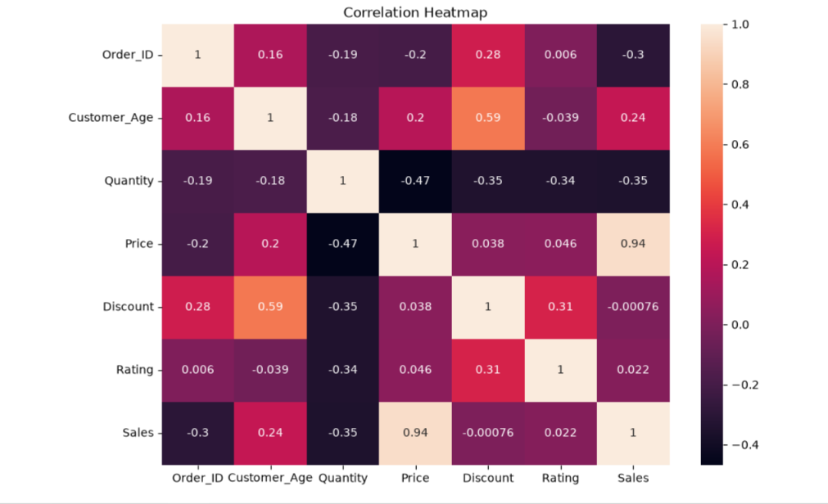
11. Correlation Heatmap

A correlation heatmap is used to identify the relationship between numerical variables in the dataset.
The correlation coefficient ranges from -1 to +1. A value close to +1 indicates a strong positive relationship, a value close to -1 indicates a strong negative relationship, and a value close to 0 indicates a weak or no linear relationship.

Observation:
The correlation heatmap shows the relationship between the numerical variables in the E-Commerce Sales Dataset.
The most significant relationship can be observed between Price and Sales, with a correlation coefficient of 0.94. This indicates a very strong positive correlation, meaning that higher product prices are strongly associated with higher sales amounts.
Customer_Age and Discount have a correlation of 0.59, indicating a moderate positive relationship between customer age and discount.
Quantity and Price have a correlation of -0.47, showing a moderate negative relationship. This indicates that higher-priced products tend to be associated with lower quantities in this dataset.
Quantity and Sales have a correlation of -0.35, indicating a weak-to-moderate negative relationship.
Discount and Rating have a correlation of 0.31, indicating a weak positive relationship.
The correlation between Discount and Sales is approximately 0 (-0.00076), indicating almost no linear relationship between these two variables.
Similarly, Rating and Sales have a correlation of 0.022, which indicates almost no linear relationship.
Overall, Price and Sales show the strongest relationship among the numerical variables in the dataset.

11.Key Insights / Findings
• The dataset contains 20 e-commerce orders and 13 variables related to customers, products and transactions.

• The dataset contains information about customer age, gender, product category, product, quantity, price, discount, payment method, city, order date, rating and sales.

• The dataset was checked for missing values, and no missing values were found in the available records.

• The dataset was also checked for duplicate records to ensure the quality of the data.

• The category-wise analysis helps identify the distribution of orders across different product categories.

• The payment method analysis shows the different payment methods used by customers for their purchases.

• The sales analysis helps understand the distribution of sales amounts across different orders.

• The category-wise and city-wise sales analysis helps compare the contribution of different categories and cities to overall sales.

• The correlation analysis shows a very strong positive correlation of 0.94 between Price and Sales.

• Quantity and Price show a negative correlation of -0.47, indicating that higher-priced products tend to be associated with lower quantities in this dataset.

• Discount and Sales have a correlation close to zero (-0.00076), indicating almost no linear relationship between them in this dataset.

• Rating and Sales also show almost no linear relationship, with a correlation of 0.022.

Conclusion
Exploratory Data Analysis was performed on the E-Commerce Sales Dataset to understand its structure, characteristics, patterns and relationships.
The analysis included dataset exploration, data quality checking, categorical analysis, sales analysis, relationship analysis and correlation analysis. Various visualizations such as bar charts, histograms, scatter plots and a correlation heatmap were used to understand the data effectively.
The analysis shows that the dataset contains useful information about customers, products, sales, discounts, payment methods, cities and ratings. One of the major findings from the correlation analysis is the strong positive relationship between Price and Sales, with a correlation coefficient of 0.94.
Overall, EDA provides a better understanding of the available e-commerce data and helps identify important patterns and relationships that can be useful for further data analysis and business decision-making.

